SIT743 Multivariate and Categorical Data Analysis

Assignment-1

### Question:1)

**Code:**

#Great Bareer Reef Data Question 1

the.data <-as.matrix(read.csv("GBRData.csv", header = TRUE, sep = ","))

my.data <- the.data [sample(1:556,250),c(1:4)]

write.table(my.data,"Ashutosh-217669865-GBRMyData.txt")

* 1. **Code:**

hist(my.data[,1],col="green", main="Histogram for HeronIsland-Salinity",xlab="Salinity Values")

hist(my.data[,2],col="green", main="Histogram for HeronIsland-Water Temperature",xlab = "Temperature Values")

**Output:**

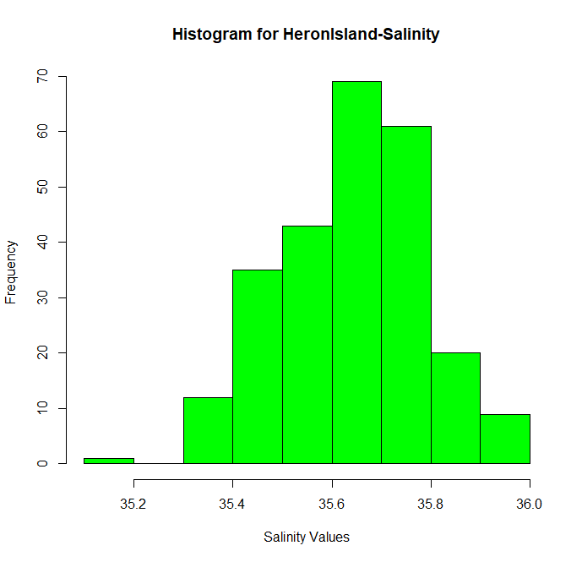

As we can see that the histogram is Unimodal and left (negative)skewed as there are higher values on the right and it tails towards left. It also has several outliers at its left i.e. the lower values of low frequency.

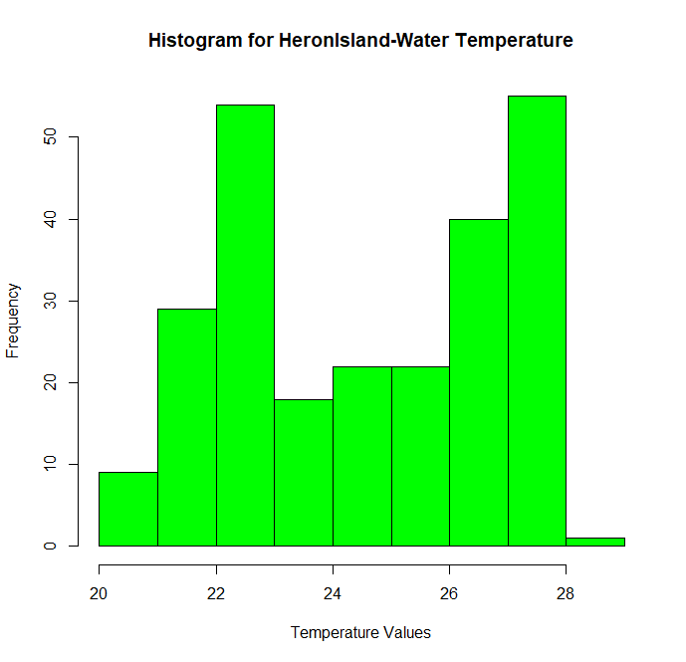

Here we can see that the histogram is Bimodal, and it is also negatively skewed a bot as higher values are accumulated at the right.

* 1. **Code:**

boxplot(my.data[,2],my.data[,4],main="Boxplot of HeronIsland-Water

Temperature’ and the ‘LadyMusgrave-Water Temperature",xlab="Different Water Temperatures",names=c("HeronIsland-Water

Temperature","LadyMusgrave-Water Temperature"),col=c("green","#0099CC"))

summary(my.data[,2])

summary(my.data[,4])

**Output:**

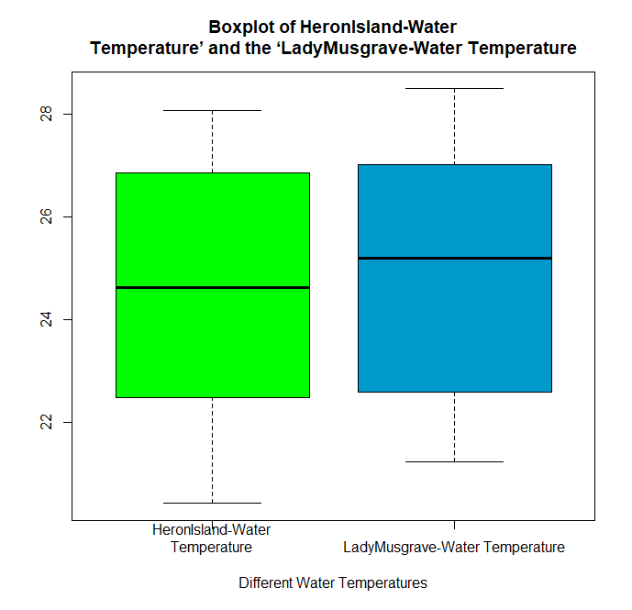

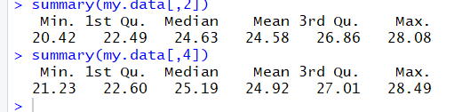

Comments:

* Lady Musgrave Water Temperature has higher interquartile range when compared to HeronIsland’s which means that data of Lady Musgrave Water Temperature have higher variation in comparison to HeronIsland’s Water Temperature.
* HeronIsland’s Water Temperature is more balanced in terms of quartiles rather than Lady Musgrave Water Temperature around the median.
* The max and min value for HeronIsland’s Water Temperature is 28.08 and 20.42 respectively whereas for Lady Musgrave Water Temperature it is slightly higher that of 21.23 and 28.49
* The means of both are 24.58 and 24.92 respectively.
* Now, the median is where both can be distinguished which is 24.63 and 25.19(larger to lady Musgrave)

1.3)**Code:**

e<-cbind(my.data[,2],my.data[,3])

plot(my.data[1:150,2],my.data[1:150,3],xlab = "HeronIsland-Water Temperature", ylab="LadyMusgrave-Water Temperature",col="red")

**Output:**

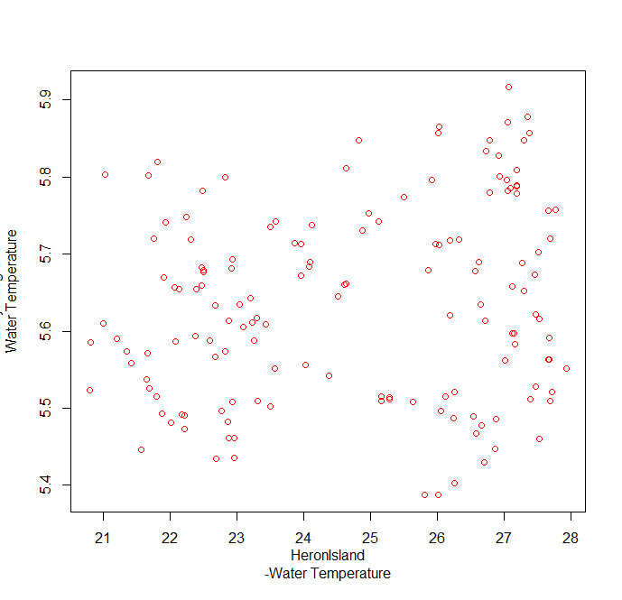

* Here we see all the points are scattered variably.
* From the above figure it can be said that it has weak relationship as there are huge

variations as the data points are widely spread across the plot

Equation of Linear regression line:

**Y = 2.719*X +(9.256)**

It’s in the following form

***Y = a + bX***,

Where:

• ***X*** is the explanatory variable

• ***Y*** is the dependent variable.

• ***b*** is the slope of the line.

• ***a*** is the intercept (the value of ***y*** when ***x*** = 0).

**Code:**

lm(e[,1]~e[,2])#linear model fitting

abline(lm(e[,2]~e[,1]),col="blue")

**Output:**

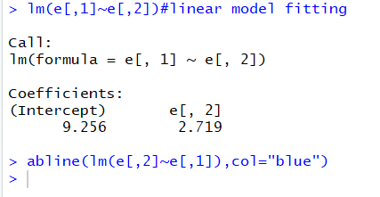

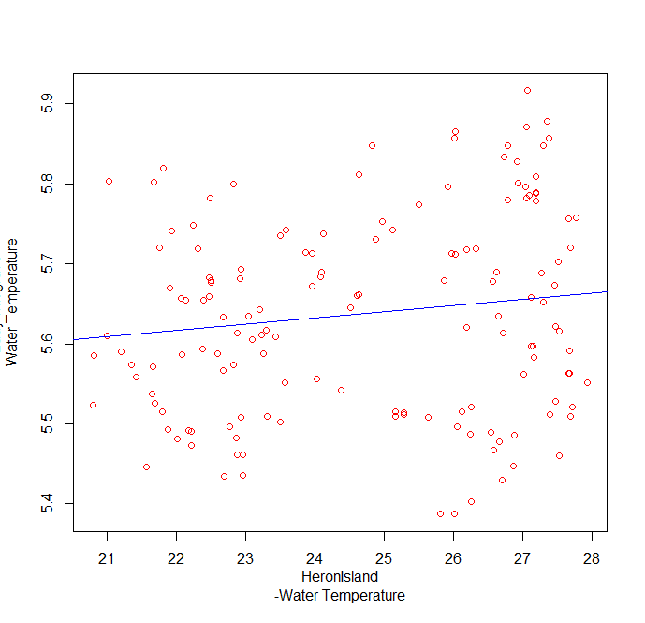

**Code:**

correlation <- cor(e[,2],e[,1])

print(paste("Correlation Co-efficient = ",correlation))

coeffDet <- correlation^2

print(paste("Co-efficient of determination = ",coeffDet))

**Output:**

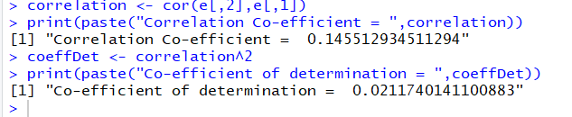

🡪The correlation coefficient between the two is 0.145512934511294

And Co-efficient of determination = 0.0211740141100883.

* The result of “*Co-efficient of correlation*” is the strength of the linear relationship. The result is positive which means that temperatures are correlated.
* The result of “*Co-efficient of determination*” or the “squared correlation” gives the result of variance. In this case it is less than 0.2 which means that there is low variance.

### Question:2)

### 

2.1) the probability that the person is a Professional ( P ) is 52.96 %.

2.2) the probability that the person is below 30 years old is 42.59%.

2.3) person’s occupation is community service (C) and the

age is between 30 and 50 years old (M) is 0.037

2.4) Probability that the person is a sales worker (S) given that he/she is above 50 years old (A) is 0.114.

2.5) the probability that the person, who is a professional (P), is below 30 years old (B) is 0.104.

2.6) Probability that the person is a sales worker ( S) or between 30 to 50 years old (M) is 0.644.

2.7) marginal distribution of the occupation:

* Professional = 0.529
* Sales Worker = 0.2
* Community Service = 0.270

2.8) marginal distribution of the Age Group:

* Professional = 0.425
* Sales Worker = 0.444
* Community Service = 0.129

2.9) Are the variables ‘occupation’ and ‘Age group’ independent random variables? Explain why or why not?!

Yes, they are as P(A intersection B) = P(A) X P(B).

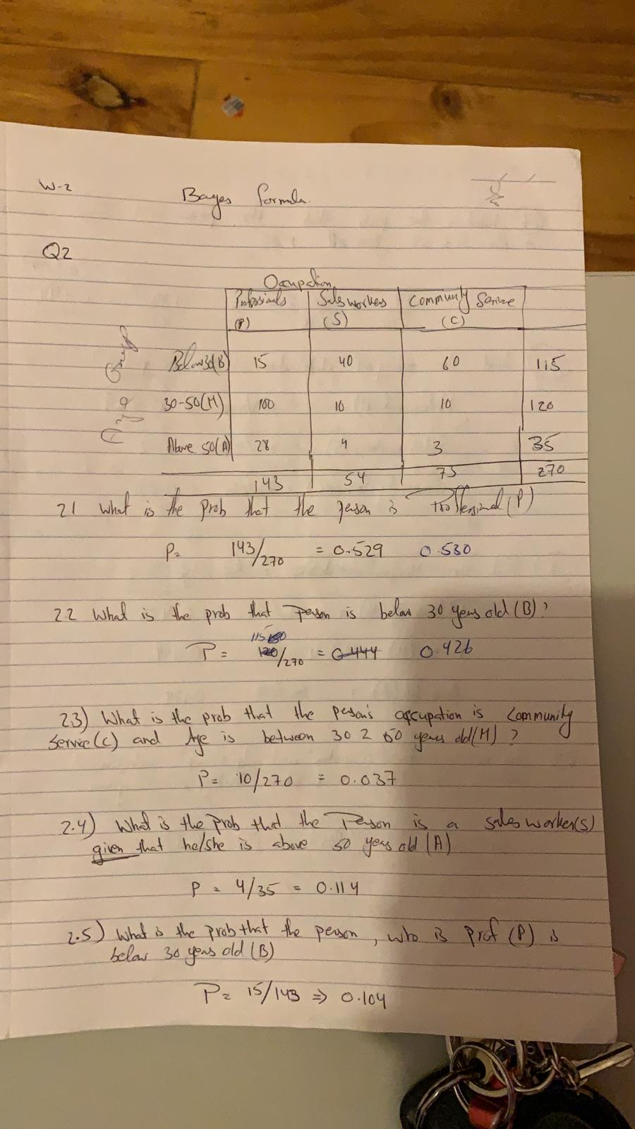

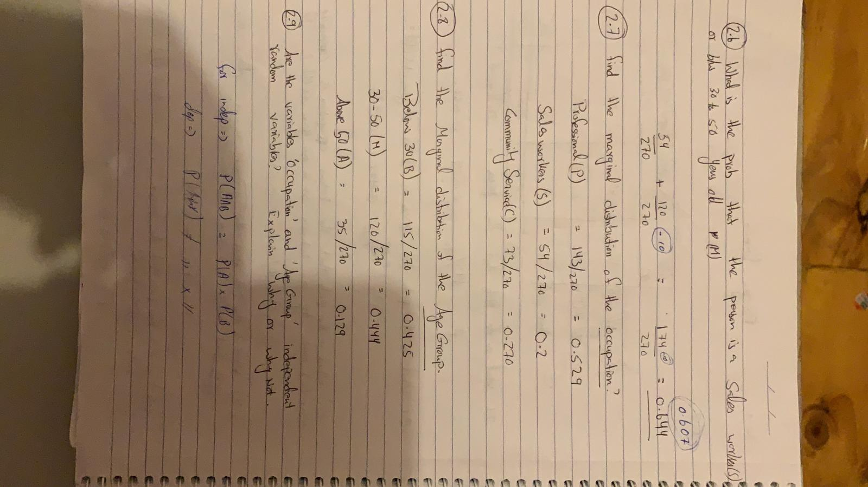

### Question:3)

1. overall proportion of the drones produced pass the quality test is 0.66 or 66%.
2. probability that it was produced by assembly line B is 0.364 or 36.46%.



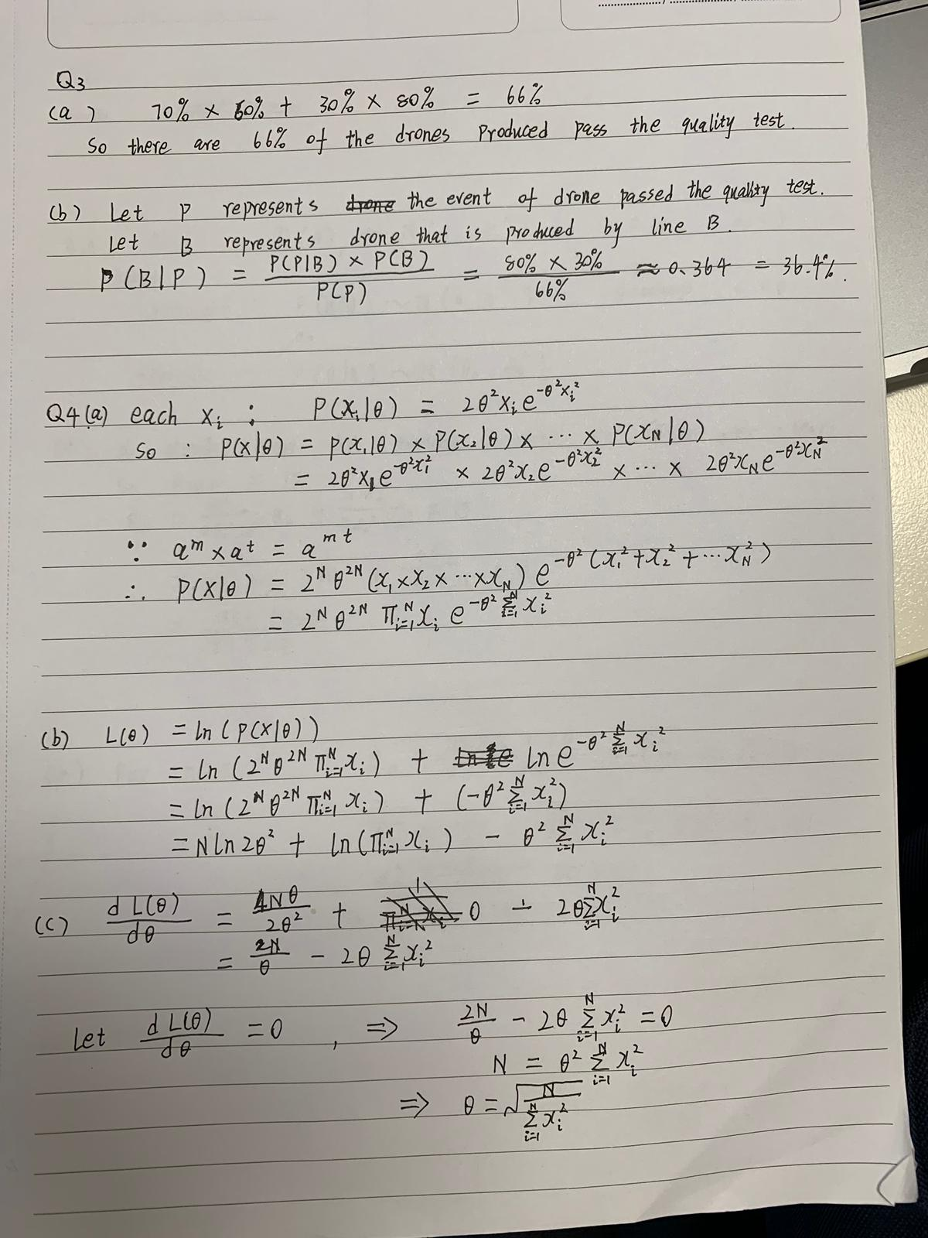

### Question:4)



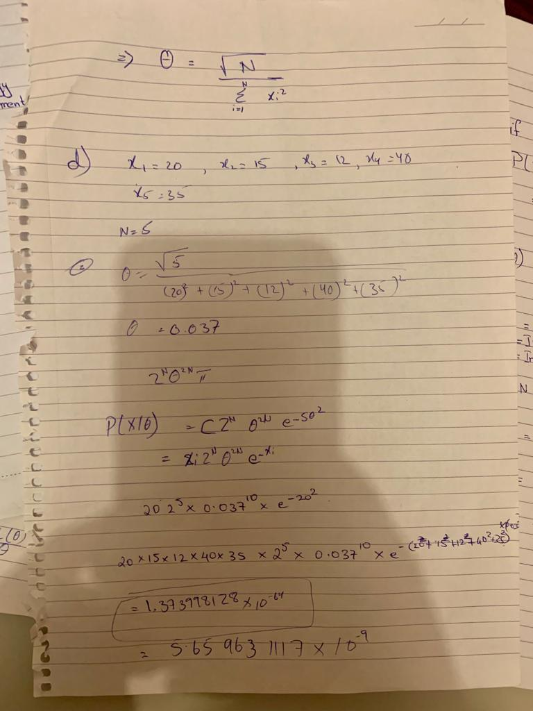

### Question:5)

5.1:

A family ‘F’ of prior distributions **p(θ)** is conjugate to a likelihood **p(D|θ),** if the posterior

**p(θ|D)** is in F then it can be said as Conjugate prior.

5.2:

If prior belong to distribution(other than Bayesian) then we need to calculate integrals and

update the variables where as if it’s in the form of conjugate priors then we only need to

update it.

5.3:

1. Gaussian – Gaussian Model

2. Beta is conjugate to Bernoulli Model

3. Dirichlet multinomial model

5.5)

In terms of mean and standard deviation we have the following values for both the sub questions:

(b) the mean is 13.214 and standard deviation is 1.793.

(c) the mean is 12.82 and standard deviation is 1.185.

(d) for D we have the mean and standard deviation of posterior as 13.9130 and 0.715.

**Code:**

#Question 5

colors <- c("black", "blue", "red")

labels <- c("prior (mean=10, var=1)", "liklihood (x1=13.9130, var=0.511)", "posterior")

#prior

mean=10; sd=sqrt(1)

x <- seq(-10,10,length=200)*sd + mean

hx <- dnorm(x,mean,sd)

plot(x, hx, type="n", xlab="", ylab="", ylim=c(0, 0.4),main="Bayesian estimation",axes=TRUE)

lines(x, hx, lwd=2, lty=c(1, 1, 1, 1, 2), col=colors[1])

#liklihood

mean1=13.9130; sd1=0.715

hx <- dnorm(x,mean1,sd1)

lines(x, hx,lwd=2, col=colors[2])

legend("topleft", inset=.005,

labels, lwd=2, lty=c(1, 1, 1, 1, 2), col=colors)

#posterior

mean2=18/7; sd2=sqrt(12/7)

hx <- dnorm(x,mean2,sd2)

lines(x, hx,lwd=2, col=colors[3])

legend("topleft", inset=.005,

labels, lwd=2, lty=c(1, 1, 1, 1, 2), col=colors)

**Output:**

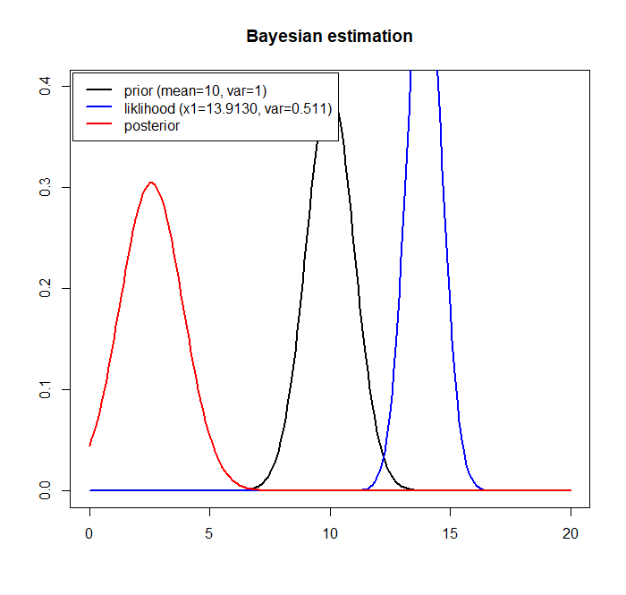

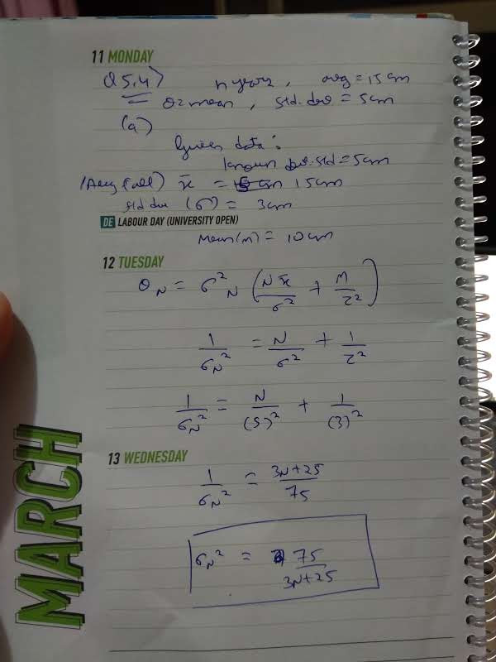

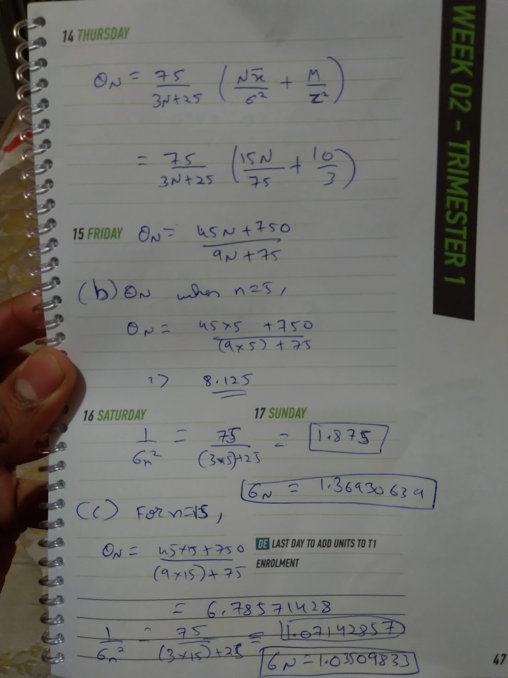

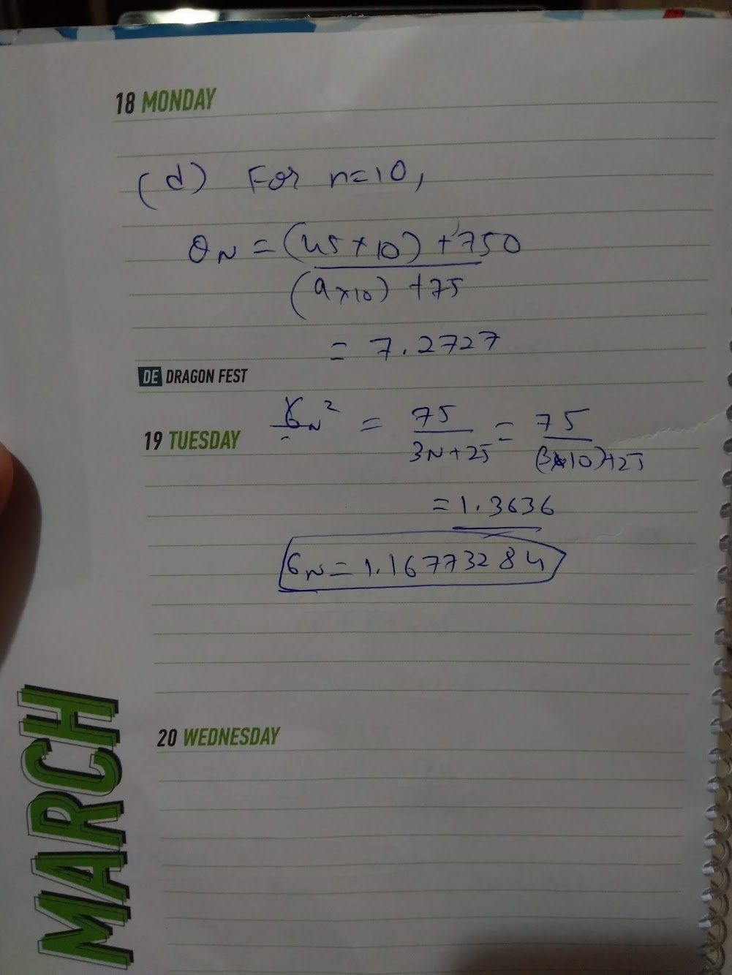

### Question:6)

**6.1) Code:**

zz<-read.table("SITEdata2019.txt")

zz<-as.matrix(zz)

1. **Code:**

zz

plot(zz[,1],zz[,2])

**Output:**

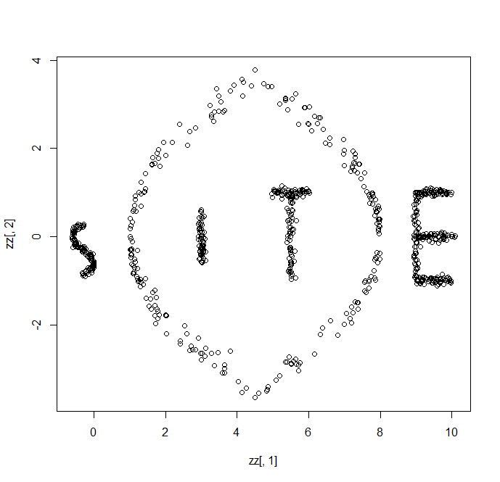

1. There are 5 clusters to be found in the plot by visual examination of the scatterplot.
2. **Code:**

#K means

library(stats)

km <- kmeans(zz, centers=5, nstart=5)

plot(zz, col=km$cluster)

**Output:**

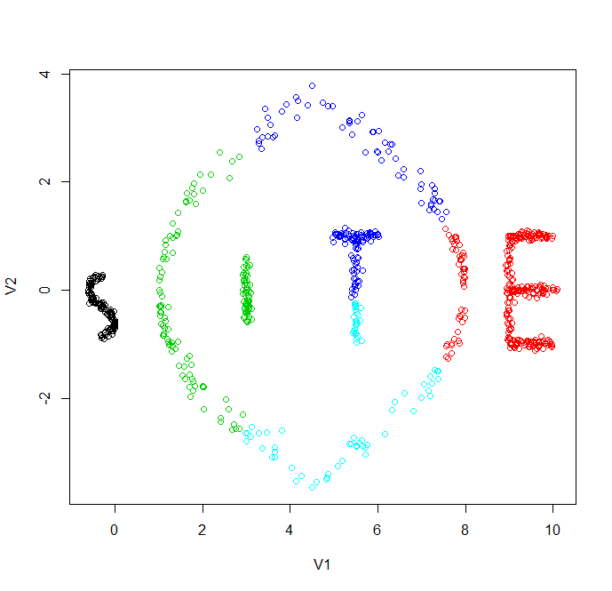

From this we can see that data points are arranged in terms of different colours each representing a cluster when we start with assumed centres to be 5.Here we see that points can be vivid in terms of final arrangement of different clusters according to black, green, blue, light blue and red colour.

1. **Code:**

#K means

library(stats)

km <- kmeans(zz, centers=15, nstart=5)

plot(zz, col=km$cluster)

**Output:**

For 15 clusters

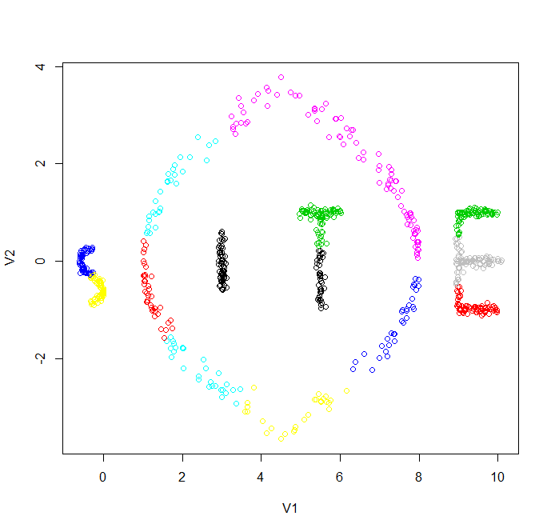

**Code:**

#K means

library(stats)

km <- kmeans(zz, centers=20, nstart=5)

plot(zz, col=km$cluster)

**Output:**

For 20 clusters

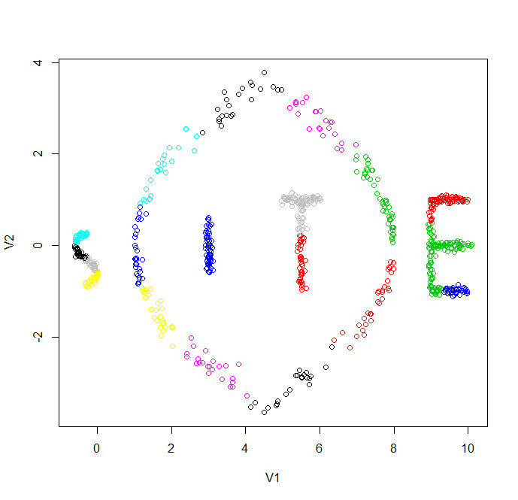

Here we see as we form more and more clusters the data becomes more specialised and more colours obtained on the graph represents more clusters formed.

**Code for Total within sum of squares (TOTWSS) value for each k:**

r <- 2:20

gph <- c()

for (i in r) {

cluster <- kmeans(zz,i)

gph <- rbind(gph,c(cluster$tot.withinss))

}

plot(gph,xlab = "Number of Clusters",xlim=c(1,length(r)),ylab = "TOTWSS (Total within sum

of squares)",main = "Plot of TOTWSS at different number of Clusters",type="o")

**Output:**

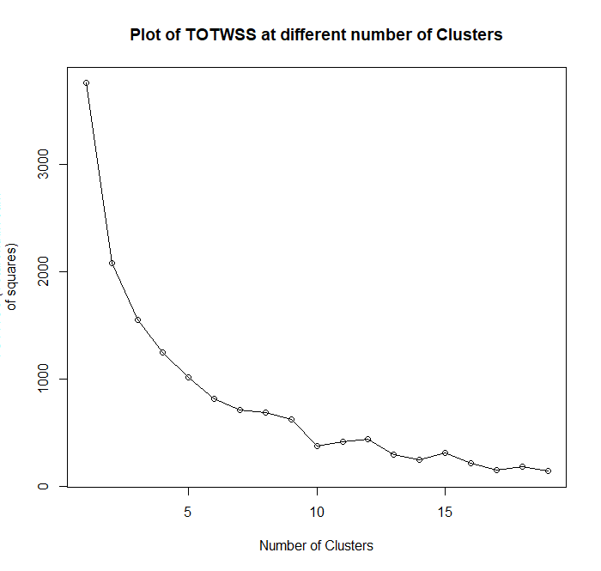

🡪The within-cluster sum of squares is a measure of the variability of the observations within

each cluster and k=16 cluster formation is the most compact when compared to other K

values.

6.2)Spectral Clustering:-

Code:

#Task 6.2

#Spectral Clustering

install.packages("kernlab")

library(kernlab)

specClust<-specc(zz, centers=4)

plot(zz, col=specClust,xlab='X',ylab="Y")

{ or alternatively the long method given in comments in R

**Output:**

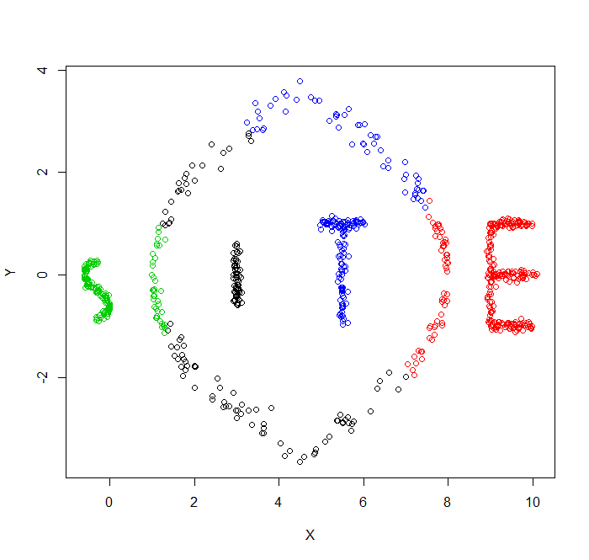

• **Spectral clustering:** data points as nodes of a connected graph and clusters are found by partitioning this graph, based on its spectral decomposition, into subgraphs.

**• K-means clustering:** divide the objects into k clusters such that some metric relative to the centroids of the clusters is minimized.

Here we can see that clusters are more accurately and significantly represented in spectral due to their spectral decomposition whereas k-means merely divides them in clusters of value k and then finalizes them to reap similar results.

I believe spectral clustering is more better arrangement to the data representation.

While KMeans uses Euclidian distance and split the data points such that it is relative to

centroid on the other hand Spectral Clustering divides the graph into subgraph. Which in

turn is more effective approach.

### Question:7)

**Code:**

#Question 7

the.data <-as.matrix(read.csv("GBRData.csv", header =TRUE, sep = ","))

#extract the 'LadyMusgrave-Water Temperature' values

LMWTdata <-the.data[,4]

**7.1) Code:**

plot(LMWTdata,main="Time series plot of LMWTData")

**Output:**

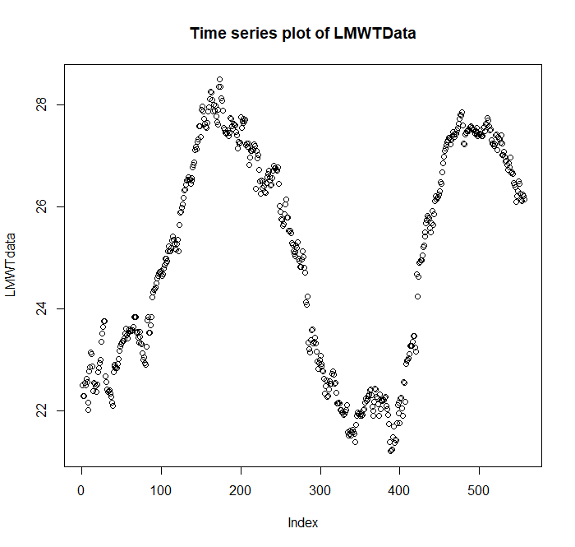

7.2) **Code:**

hist(LMWTdata,main = "histogram for LMWT data")

**Output:**

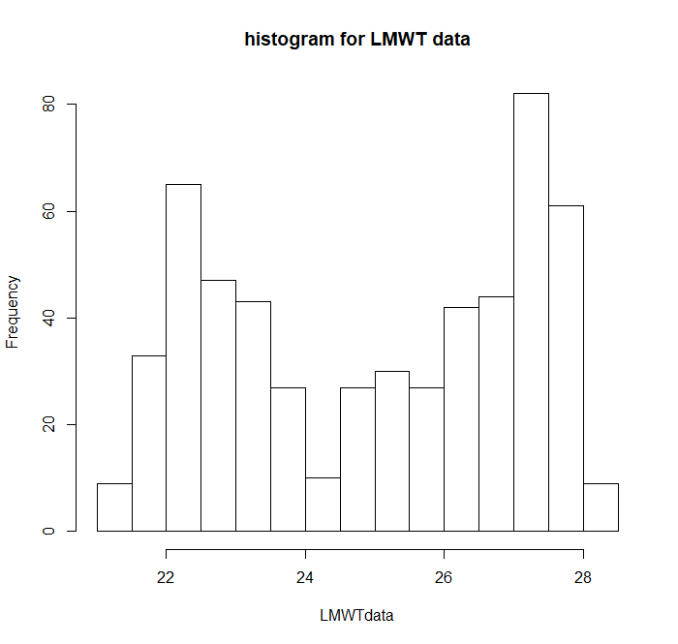

Here we can observe that it is bimodal as there are two peaks at different points in the graph at both ends left and right.

7.3) **Code:**

library(MASS)

fit1<-fitdistr(LMWTdata,"normal")

fit1

mixmdl = normalmixEM(LMWTdata)

mixmdl

summary(mixmdl)

plot(mixmdl,which=2)

**Output:**

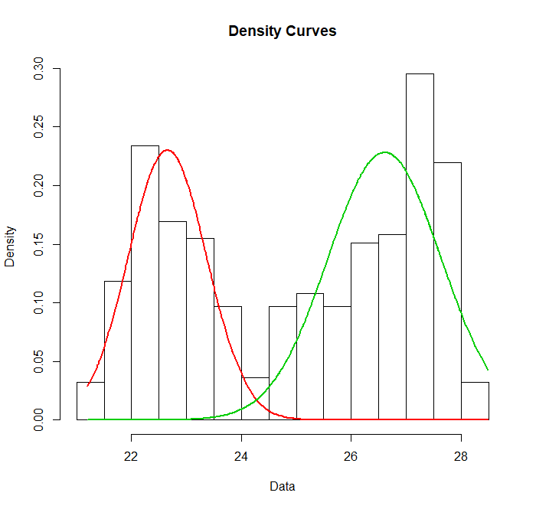

7.4) **Code:**

lines(density(LMWTdata), lty=2, lwd=2)

mixmdl$lambda

mixmdl$mu

mixmdl$sigma

**Output:**

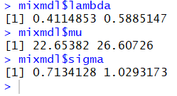

7.5) **Code:**

lines(density(LMWTdata), lty=2, lwd=2)

**Output:**

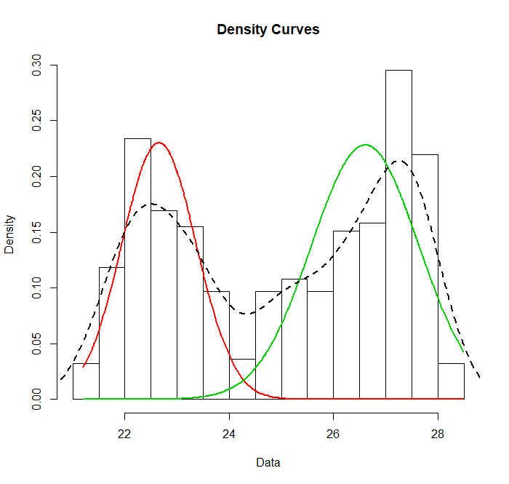

7.6) **Code:**

plot(mixmdl$all.loglik)

**Output:**

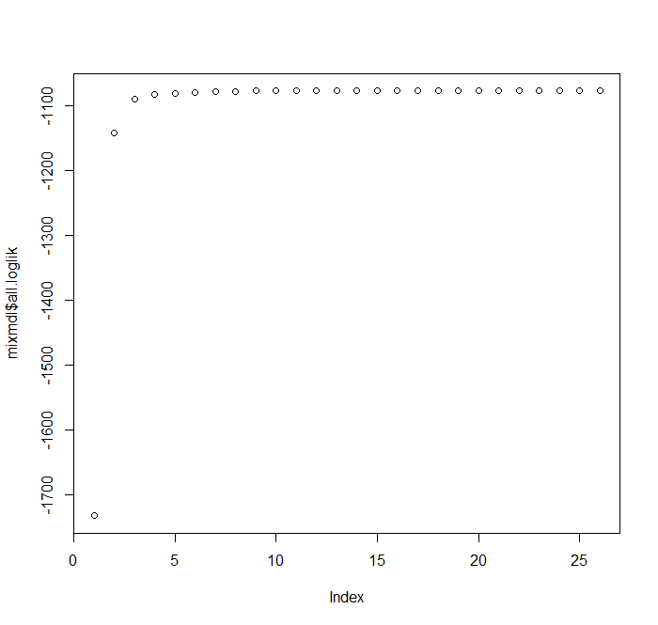

7.7) the distribution modes obtained in Q7.3 and Q7.4 show gaussian fitting of the graphical data in various representations.

We see one represents two curves whereas other one represents one curve with two peaks.

I think mixture of Gaussians models is more ideal method coz it fits the whole data and shows it in a streamlined and univariate manner which helps in seeing the entity as generalised and whole and makes predictions and analysis easy.

7.8)The main problem that you might come across when performing a

maximum likelihood estimation using mixture of Gaussian is singularity.If we want to fit a Gaussian to a single data point using maximum likelihood, we will get a very spiky Gaussian that "collapses" to that point. The variance is zero when there's only one point, which in the multi-variate Gaussian case, leads to a singular covariance matrix, so it's called the singularity problem.

When the variance gets to zero, the likelihood of the Gaussian component goes to infinity and the model becomes overfitted. This doesn't occur when we fit only one Gaussian to a number of points since the variance cannot be zero. But it can happen when we have a mixture of Gaussians.

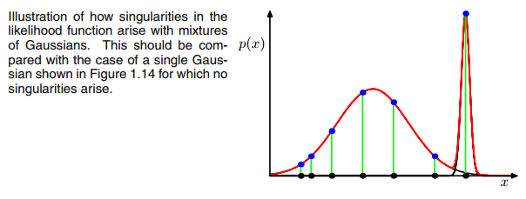

The solutions for such a problem are:-

1. resetting the mean and variance when singularity occurs

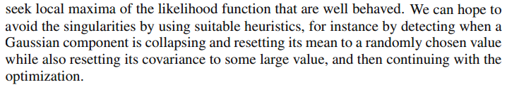

1. using MAP instead of MLE by adding a prior.

